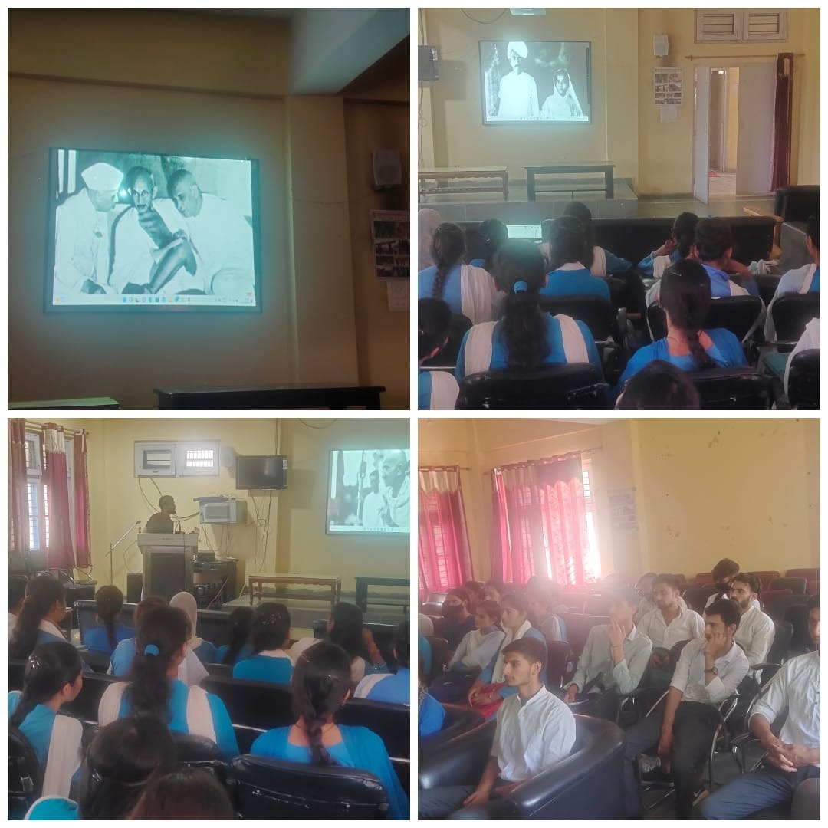**Press Release**

**GDC RAMBAN October 1, 2022:** In run upto Gandhi Jayanti celebration GDC Ramban organised series of events under the patronage of Prof Subhash Chander Sharma Principal of the college. The first event began with the singing of one of Gandhi’s favourite songs Raghupati Raghav Raja Ram by college students. Later a documentary on the life of Mahatma Gandhi was screened. A sizable number of students participated in the event. All teaching staff of the college were also present in the occasion. In the second event the NSS unit of the college conducted a Swachhta drive in the college campus. NSS volunteers cleaned the inside and outside college campus. They hand-picked trash and wrappers and dumped them in dustbins. NSS volunteers cleaned the college gate area, college parking zone, college Canteen area etc. All the events were monitored by NSS program officer, Prof Vickey Rattan and Prof Younis Ahmad Rather.

**SD/**

**P R I N C I P A L**