**Press Release**

**GDC Ramban Conducted District Level Inter-College Singing, Essay Writing and Debate Competition.**

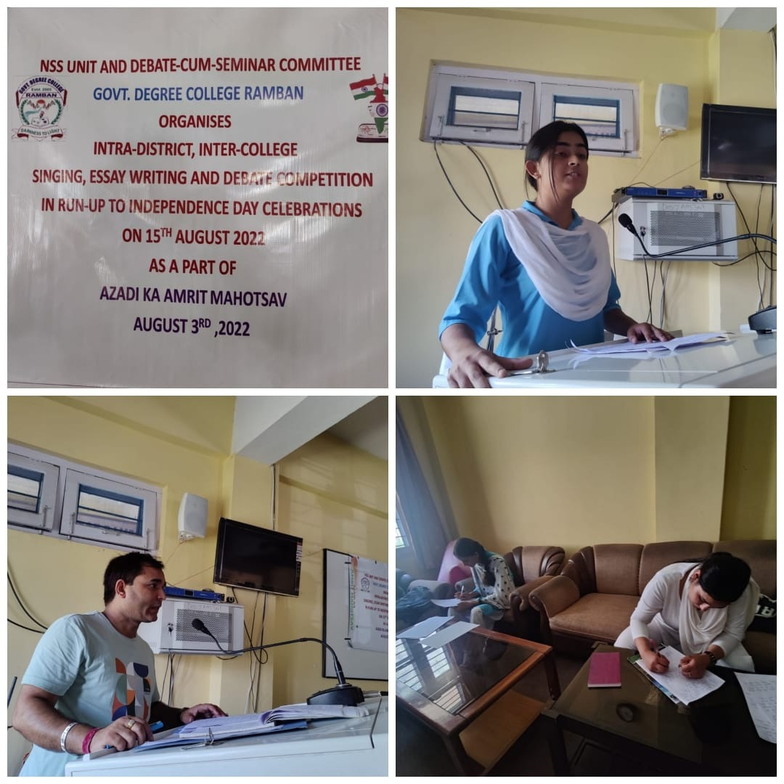

NSS and Debates &Seminar committee of GDC Ramban organised a district level inter-college competition in Debate, Singing and Essay writing in run-up to **Independence Day celebrations** on 15th August 2022 as a part of **Azadi ka Amrit Mahotsav** under the patronage of **Prof Subhash Chander Sharma,** Principal of the college. Students from GDC Ramban, GDC Gool, GDC Banihal GDC Ukhral and GDC Batote took part in the aforementioned categories of competition. A large gathering of audience both students and faculty of GDC Ramban and from other colleges were present in the event. **Ms. Shabnam Akhtar** from GDC Ramban secured the first position whereas **Ms. Mehbooba Sultan** from GDC Gool attained the second position in singing competition. **Mr. Mubashir Ahmed** from GDC Banihal secured 1st position and **Ms. Samreen Choudharry** from GDC Ramban got 2nd position in debate competition. Likewise, **Ms. Shafia Shabnum** from GDC Gool attained first position whereas **Mr Sunil Singh** from GDC Batote got 2nd position in essay writing competition. All other contestants were given certificates of participation and one medal each. **Prof Chanakya Sharma** HOD Music GDC Ramban, mesmerised the audience by his performance of a couple of Patriotic songs. **Prof Vijay Kumar Sharma** conducted the proceedings, whereas **Prof Vickey Rattan** NSS program Officer of the college played the lead role and monitored the overall conduct of activities related to the event. The program ended with the concluding remarks presented by **Prof Shah-e-Jahan Ganai** incharge Principal GDC Gool.

**SD/-**

**P R I N C I P A L**