**PRESS RELEASE**

**\*\*\*\*\*\*\*\*\*\*\*\*\*\*\*\*\*\*\*\*\*\*\*\*\*\***

**NSS Unit of GDC Ramban Conducted One Day Plantation Drive**

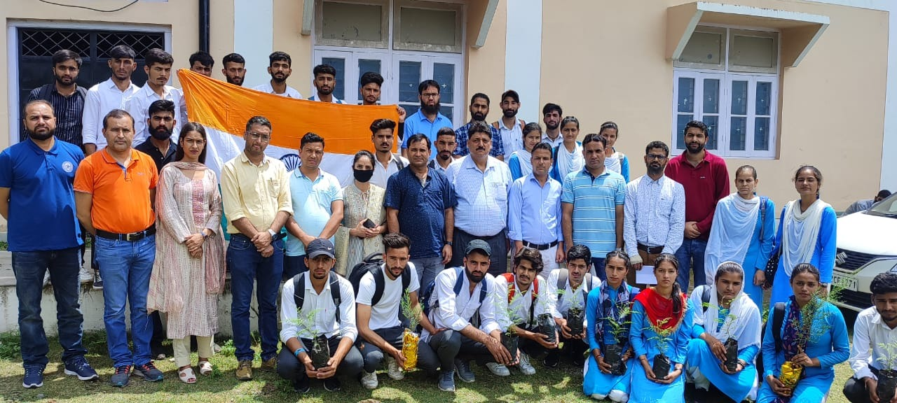

NSS Unit and staff of **GDC Ramban** conducted a plantation drive of outdoor plants on **6th of August 2022** in the campus under the aegis of **Prof Subhash Chander Sharma**, Principal of the college. As many as **fifty (50)** students participated in the plantation of saplings under the guidance and supervision of staff of the college. About 30 saplings were planted during the plantation drive. The students dug-up the pits themselves and watered the newly planted saplings. In run-up to the **Independence Day celebrations on 15th August 2022** under **Azadi Ka Amrit Mohatsav**, a staff meeting was also held in furtherance of the ***Har Ghar Tiranga campaign***. The message of the meeting was conveyed to the students with the instructions to disseminate this information to their villages and communities. The students actively participated in the plantation drive as well as ***Har Ghar Tiranga Campaign****.*

**SD/-**

**P R I N C I P A L**