**PRESS RELEASE**

**\*\*\*\*\*\*\*\*\*\*\*\*\*\*\*\*\*\*\*\*\*\*\*\*\*\***

**NSS Unit of GDC Ramban organised a rally on“Har Ghar Tiranga”campaign**

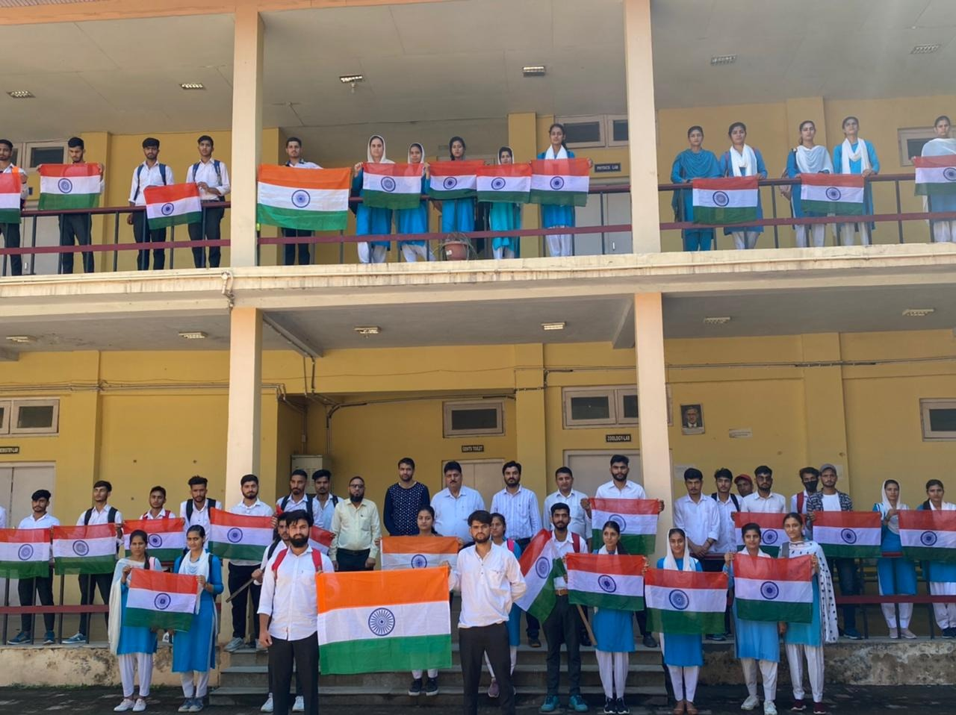

**In the context of Independence Day Celebrations on 15th August 2022 and** as a part of Azadi Ka Amrit Mahotsav, NSS unit of GDC Ramban organised “**Har Ghar Tiranga**” campaign today on 10th of August involving students and staff of the college. The activity was organized under the guidance and patronage of Prof. Subhash Chander Sharma, Principal of the college. It was aimed at sensitizing the students about the significance of Tiranga and to deliver the message to villages and communities by the agency of students making **Har Ghar Tiranga**” campaign a ssuccessful endeavor. NSS Unit of GDC Raman has conducted a number of activities so far since the beginning of August 2022 in run up to independence day celebrations on 15 August 2022. On 6th August an indoor plantation drive was conducted in the campus in which the staff and the students of college planted as many as 30 saplings in the campus. On 8th August an intra-college poster making competition was organised in furtherance of Ghar Ghar Tiranga Campaign in which more than thirty (30) students participated. Ms. Anu Devi of semester 2nd semester secured first position whereas Ms. Amesha Devi of 6th Semester and Mr. Tariq Ahmed and Mr. Anil Kumar of 3rd Semester got 2nd and 3rd position respectively. To day on 10th of August 2022, two events namely Tiranga Show in the campus and Har Ghar Tiranga Awareness Rally was organized with the participation of as many as fifty (50) students and staff of the college. The students beautifully raised Tiranga flags flying high during march in the rally .

The rally was flagged off by Prof Subhash Chander Sharma, Principal of the college. Addressing the students, Prof Subhash Chander Sharma said that bringing Tiranga to every home is not just an act of personal connection to the Tiranga but also an embodiment of our commitment to nation-building. He also said that Har Ghar Tiranga Campaign will trigger the patriotic feelings in our hearts strengthening national integration on a bigger scale. Later, he instructed the students to disseminate this information to their villages and communities. NSS program Officer Prof Vickey Rattan asked the students to pin the Tiranga to their social media accounts as DP. All the staff of the college participated in the campaign with great enthusiasm and exuberance.

**SD/-**

**P R I N C I P A L**