**PRESS RELEASE**

***GDC Ramban observed “World AIDS Day”***

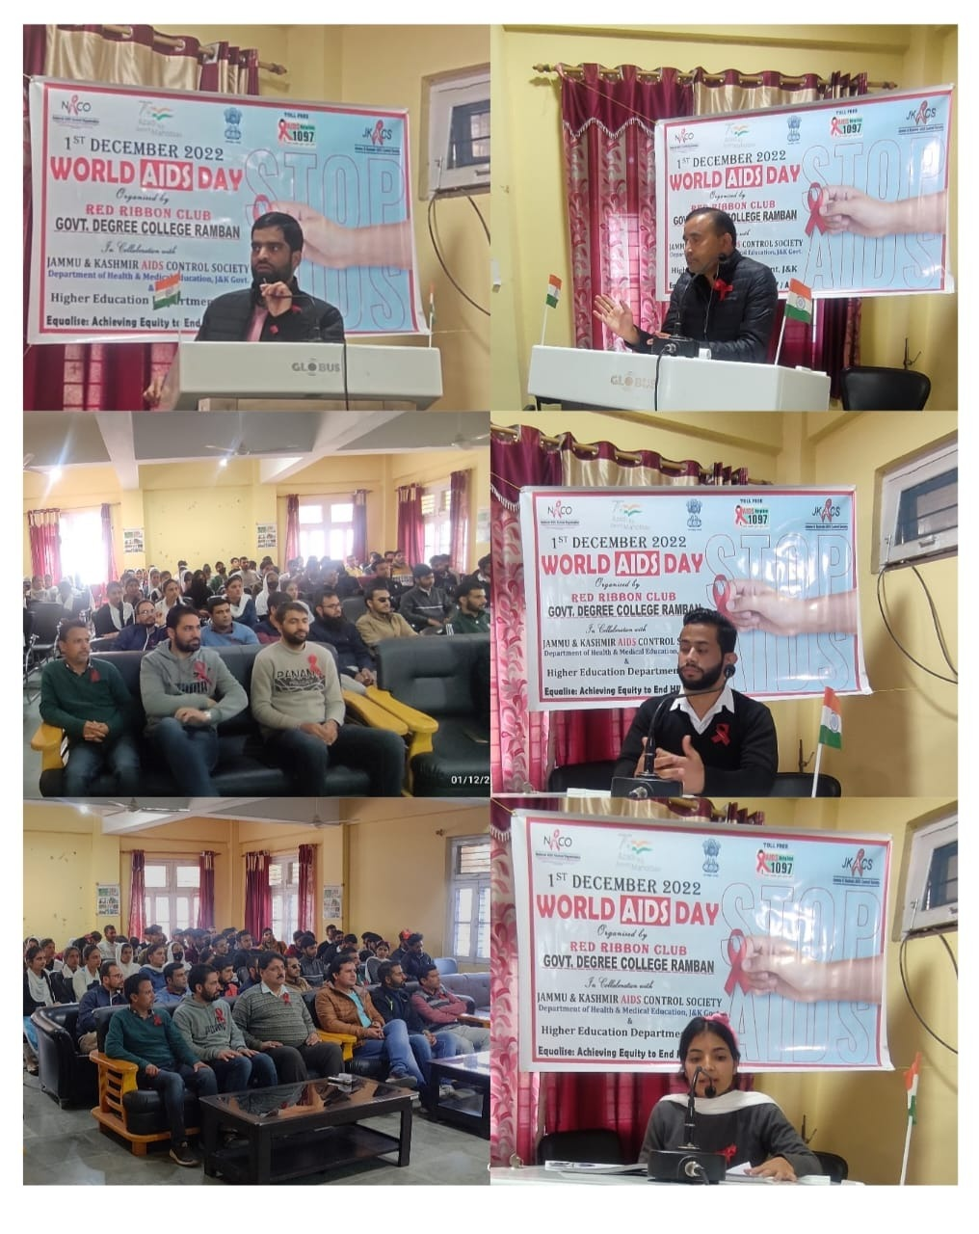GDC Ramban observed World AIDS Day on December 1, 2022. An event was organized by Red Ribbon Club of the college under the guidance and patronage of Principal, Prof Subhash Chander Sharma. A sizable student body and staff attended the Program. The convener of Red Ribbon Club, Prof Younis Ahmed Rather in collaboration with NSS Program Officer Prof Vickey Rattan, executed the planning and preparations of the programme. He also monitored the proceedings of the program and highlighted the statistics of HIV and AIDS infection cases in the nation and around the globe. The topic was covered in depth by Prof Bal Krishan, Head of the Zoology department. He provided information on risk groups and the method of HIV transmission. In order to prevent infection and sickness, he emphasised the importance of adopting healthy lifestyle choices and getting tested for HIV. He added that reducing social inequities and raising awareness through educational initiatives are necessary to eliminate the disease's societal stigma. Among Students speakers, Ms Rajni Chib, Ms Diksha Devi and Mr Mohd Shoib also made their presentations. The programme concluded with the formal vote of thanks proposed by Prof Aijaz Ahmed.