**Press Release**

**\*\*\*\*\*\*\*\*\*\*\*\*\*\*\*\*  
GDC RAMBAN ORGANISES INTRA-DISTRICT, INTER-COLLEGE SYMPOSIUM AND PLEDGE AGAINST DRUG ABUSE UNDER NASHA MUKT BHARAT ABHIYAAN**

**GDC RAMBAN:** NSS Unit and Psychological Counselling Cell GDC Ramban organised an **intra-district, inter-college symposium and Pledge against Drug Abuse** under the guidance and patronage of Prof Subhash Chander Sharma, Principal of the College under **Nasha Mukt Bharat Abhiyaan** with the theme **Say No to Drugs** on 12th August 2022 as part of **Azadi Ka Amrit Mahotsav**. Students from GDC Ramban, GDC Banihal, GDC Ukhral and GDC Batote took part in the aforementioned Symposium. Prof Subhash Chander Sharma, Principal of the College was chief guest where as Dr Ranvijay Singh, Principal GDC Ukhral was guest of honour of the program. The program started at 11:00 am with the pledge against drug abuse in which all the staff and students of the college took pledge against drug abuse. After the pledge worthy Principal of the college in his address emphasized on the need of sensitization of teachers, students and society at large about the menace of drug abuse and drug addiction. The second segment of the program started with the welcome address by Prof Vijay Kumar. He gave a brief introduction of the program in the very beginning. He compered and conducted the proceedings of the whole program. Dr.Vikram Rathore, Dr Vinod Kumar and Prof Suresh Sharma were nominated judges to judge the performances of the participants. Mubashir Ahmed and Danish Rafiq from GDC Banihal secured 1st and 2nd position respectively. Whereas Rajni Chib from GDC Ramban got 3rd position. Participation certificates were given to all the participants whereas prizes were given to the first three position holders. The formal vote of thanks was presented by Prof Vickey Rattan, NSS program officer. All the staff of the college participated in the program. The whole event was organised by Prof Vickey Rattan, NSS program officer and Prof Younis Ahmad Rather.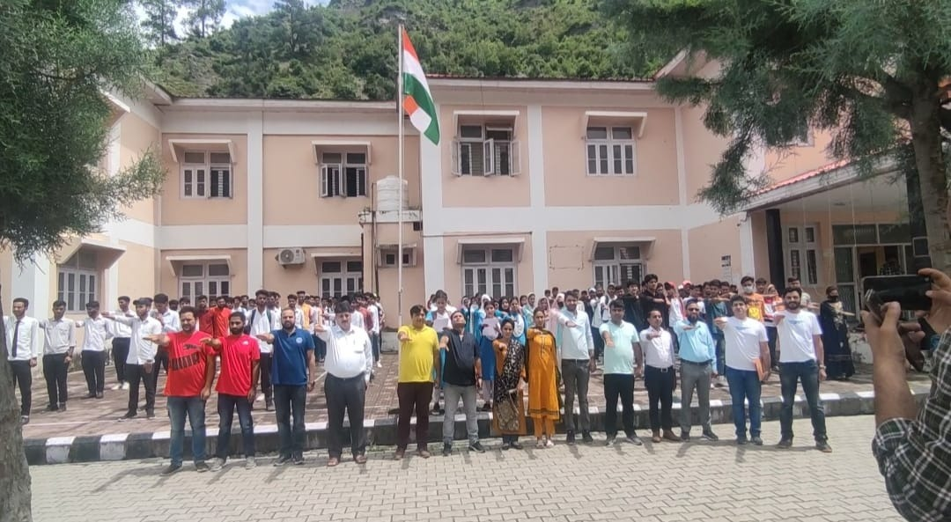

**SD/-**

**P R I N C I P A L**