**Press Release**

******************

**On 30-09-2022, GDC Ramban organized two events: one to commemorate Gandhi Jayanti and one on substance abuse as a part of Nasha Mukt Bharat Abhiyan, under the guidance and patronage of Prof. Subhash Chander Sharma, Principal of the college. The programme was attended by a sizable number of students and faculty members. Addressing the students, the Principal of the college discussed how the threat of substance misuse can be detrimental for the society. He urged the students to abstain from drug usage and spread this message to their villages and communities in order to effect social transformation. He also shed light on Mahatma Gandhi's ideas and philosophy of truth and nonviolence and his efforts to the cause for Indian independence.**

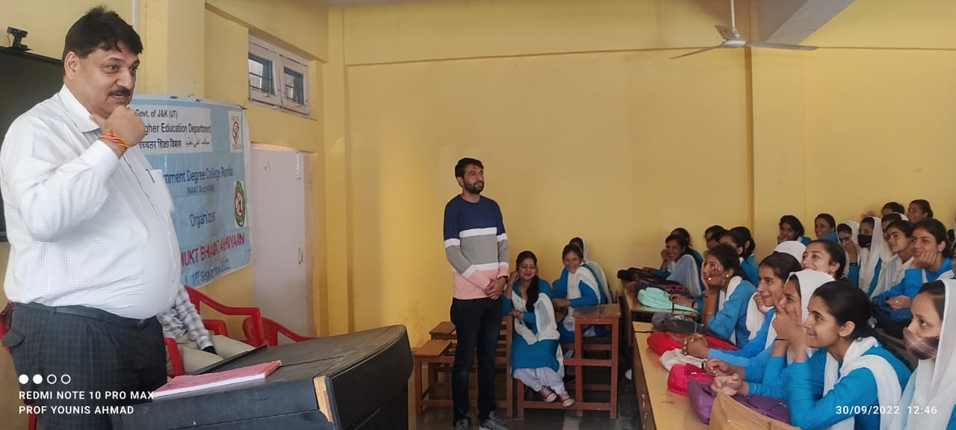

**Sd/-**

**P R I N C I P A L**