**Press Release**

**One day awareness Programme on Gender Justice and Beti Bachao Beti Padhao Campaign held at GDC Ramban.**

Today, on October 28, 2022, GDC Ramban in collaboration with Department of Social Welfare Ramban hosted an awareness session about gender equity and the Beti Bachao Beti Padhao Campaign, under the directions and patronage of Principal of the college, Prof. Subhash Chander Sharma. A sizable student body as well as all of the faculty members attended the programme. The distinguished Principal stressed the need of educating young people about gender-related issues and advancing the Beti Bachao Beti Padhao programme. Among the visiting officers from Department of Social Welfare Ramban, Ms. Madiha Wani, the child protection officer Ramban, presented a thorough explanation of the procedures that must be followed to ensure gender justice and the Beti Bachao Beti Padhao programme. She spoke face-to-face with the students and answered their questions. Mr. Vikram Singh Raju, LCPO Ramban spoke about the child rights and legal framework of juvenile justice system. Prof Bal Krishan, convener Psychological Counselling Cell of the college also shared his thoughts on the occasion. He underlined the need of conducting counselling and awareness sessions around family units to eradicate gender stereotypes, social beliefs and biases that perpetuate discrimination against girls and women in the society. He said that academic institutions and teachers need to play an active role as agents of social change apart from imparting routine educational services. The proceedings of the program were compered by Prof. Vijay Kumar Sharma. Prof Vickey Rattan, NSS Program Officer of the college, monitored the event's overall planning and preparations. The program concluded with the vote of thanks proposed by Prof Younis Ahmad Rather.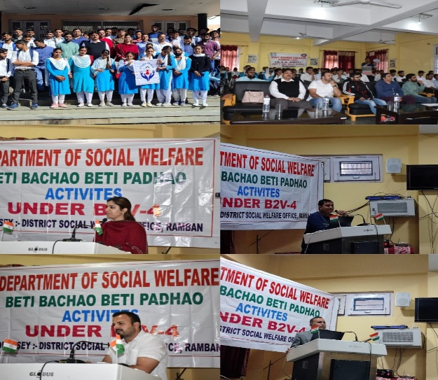

**SD/**

**P R I N C I P A L**