**Press Release**

**GDC Ramban held District Level Inter-College competition in run up to celebration of Gandhi Jayanti**

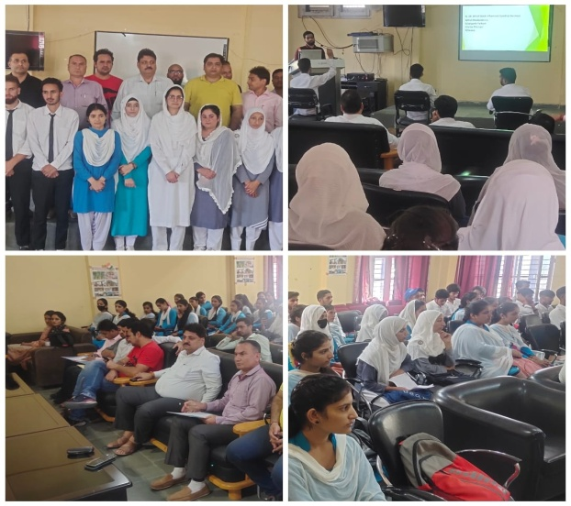 **GDC Ramban 26, September 2022:** As a part of Gandhi Jayanti celebrations, GDC Ramban organized a district level inter-college competition in three categories namely 1. Declamation on the Topic “Relevance of Gandhian Philosophy in the Contemporary Times” 2. On the spot Painting/Poster making competition on the themes: Life Sketch of Mahatma Gandhi, Dandi Marc and Quit Indian Movement 3. Quiz on life and Philosophy of Mahatma Gandhi. The competition was held under the aegis of Principal of the college, Prof. Subhash Chander Sharma. Earlier, the message regarding the activities of the competition was conveyed to Principals of Degree Colleges, Batote, Banihal, Gool and Ukhral. Prof. S A Ganie from GDC Gool, Deepak Kumar PTI from GDC Banihal and Prof Aashiq Ahmad parray from GDC Batote along with student contestants from their respective colleges, attended the competition event. All the participants and competitors were ecstatic with the competition's activities designed to illustrate Gandhi ji's truth and non-violence philosophy in contemporary society. In first category of competition, namely declamation on the Topic “ Relevance of Gandhian Philosophy in the Contemporary Times” Rajni Chib from GDC Ramban, Mehrooka Tabassum from GDC Gool and Mubashir Ahmad from GDC Banihal attained first, second and third positions respectively. Similarly Mehwish from GDC Batote, Snober Wani from GDC Banihal and Kazima Farid from GDC Gool secured first, second and third positions respectively in Painting/Poster making competition. And Danish Rafiq from GDC Banihal, Ravinder Singh from GDC Ramban and Shugafta Afreen from GDC Gool got first, second and third positions respectively in Quiz Competition. The activities of the competition were planned and prepared jointly by NSS unit and Psychological Counseling Cell of the College. A sizable body of student and all faculty of the College attended the competition event.

*Sd/-*

P R I N C I P A L