**PRESS RELEASE**

**TEACHER’S DAY CELEBRATED WITH EXUBERANCE AND GAIETY AT**

**GDC RAMBAN**

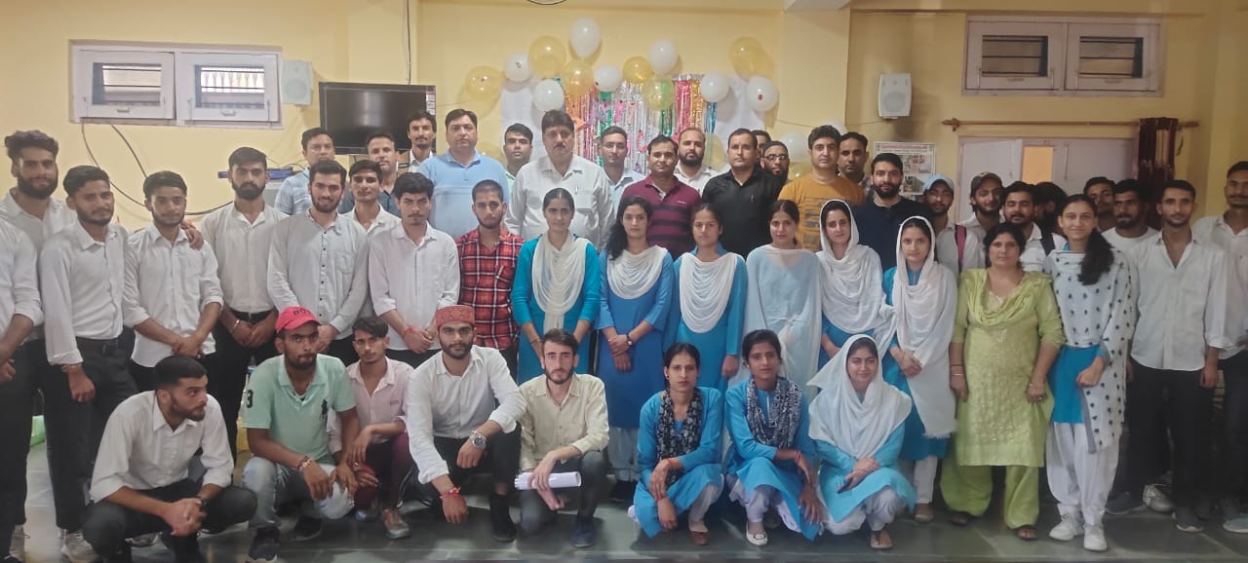**GDC RAMBAN:** On September 5th, 2022, the faculty of GDC Ramban organised an event under the aegis of the college Principal Prof. Subhash Chander, Sharma, to celebrate teacher’s day and pay tribute to one of history's greatest educators, **Dr. Sarvepalli Radhakrishnan**, a fervent advocate of education and the second President of India.

About seventy (70) students and staff members attended the programme, which began at 11 am. Speaking on the occasion, Principal of the college, Prof Subhash Chander Sharma underlined the need of conscious, consistent and catalytic role of faculty in realisation of goals of quality enhancement and sustenance of the college to achieve excellence in all aspects of its functioning. Expressing his ideas, Prof Bal Krishan stated that teachers must be professionally competent to engage students and inspire them to become self-motivated learners with the capacity to adapt to new jobs and skills in a rapidly changing global environment. Students presented a variety of cultural items in honour of the teachers. They portrayed and mimicked their teachers in a variety of activities in a classroom setting to project valuable feedback. Prof. Vickey Rattan, NSS Program Officer, monitored the event's planning and preparations leading up to Teachers Day.

**SD/-**

**P R I N C I P A L**